**Influencer Impact Analysis - Entertainment Sector**

Pooja Joshi & E.Code [E25007]

# Overview :

This report presents an analysis of the impact of influencer campaigns on movie performance metrics such as popularity, vote count, vote average, and attendance. The analysis compares the performance of movies before and after the influencer campaign using statistical tests and visualizations to quantify the impact.

# Objective:

The primary objectives of this analysis were:

To determine how influencer campaigns affect key movie performance metrics.

To compute the percentage change and assess the significance of these changes.

To visualize the impact before and after the influencer campaign.

# Assigned Task(s) :

· Analyze the changes in popularity, vote count, vote average, and attendance before and after the influencer campaign.

· Compute the percentage changes and conduct t-tests to evaluate statistical significance.

· Generate visualizations such as line plots, bar plots, and distribution plots for the key metrics.

# Task Details :

****Task 1**: Analyze Influencer Impact on Popularity, Votes, and Attendance**  
**Status**: Completed  
**Details**: The data was split into periods before and after the influencer campaign date (2023-03-01). Percentage changes were calculated for popularity, vote count, vote average, and attendance. T-tests were applied to assess the statistical significance of the changes.

****Task 2**: Create Visualizations**  
**Status**: Completed  
**Details**: Time series, bar plots, and distribution plots were generated to visually display the changes in key metrics before and after the influencer campaign. These visualizations provided clear insights into how the influencer campaign impacted movie trends.

**Visualizations:**

1. **Popularity Over Time (Before and After Campaign)**This graph shows the drastic decline in popularity after the campaign start date (represented by the red dashed line). The blue line shows the popularity before the campaign, and the orange shows after.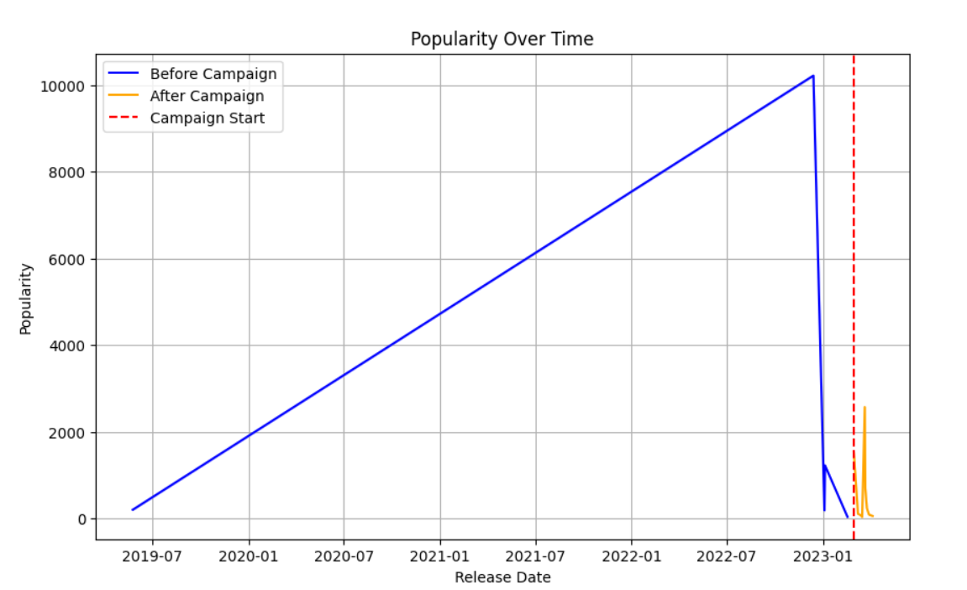
2. **Distribution of Popularity Before and After Campaign**

* The distribution plot highlights how the density of popularity shifted after the campaign, indicating a significant change in engagement.

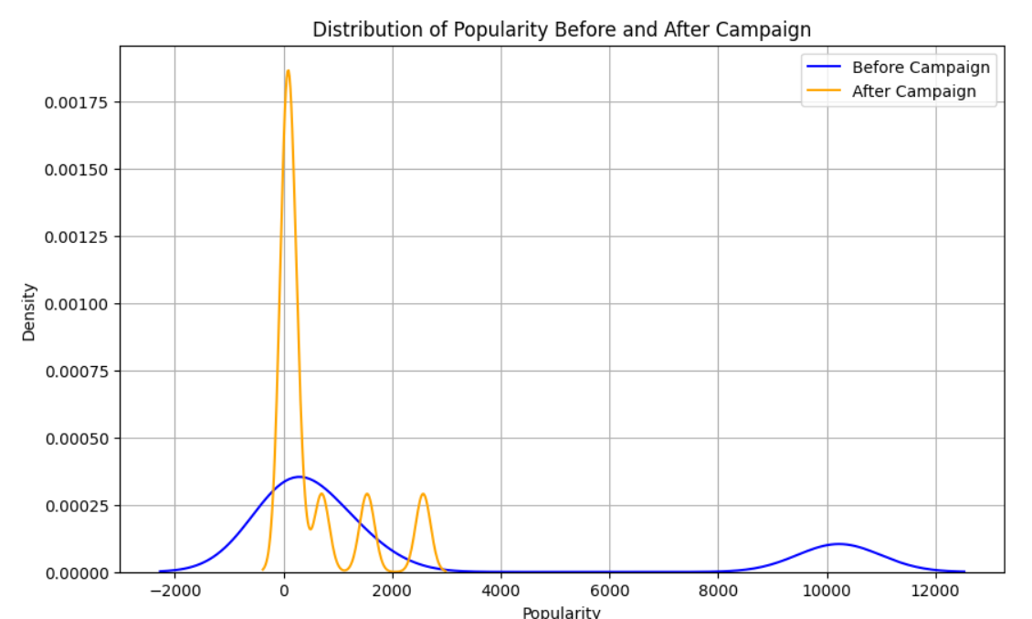

1. **Vote Count Over Time :**

This plot illustrates the sharp decline in vote count after the campaign, further supporting the findings from the popularity metric.

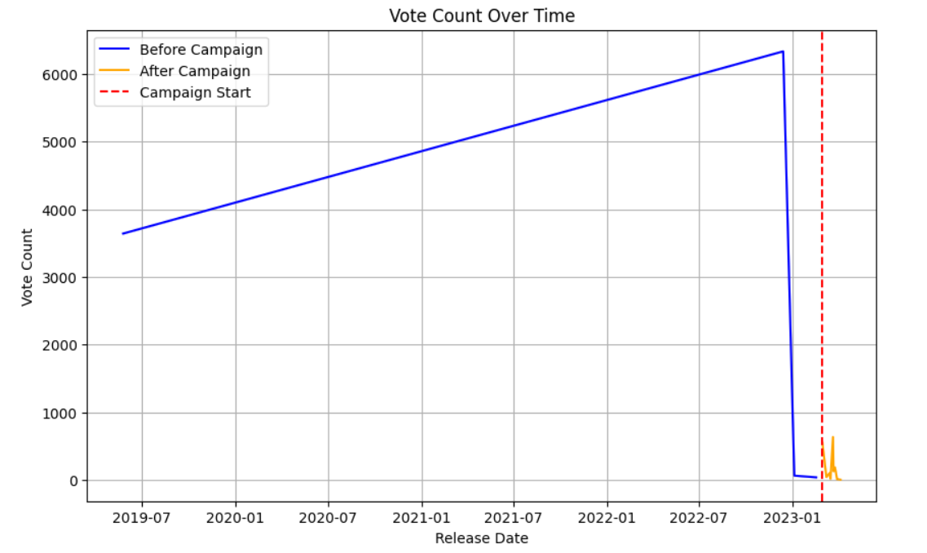

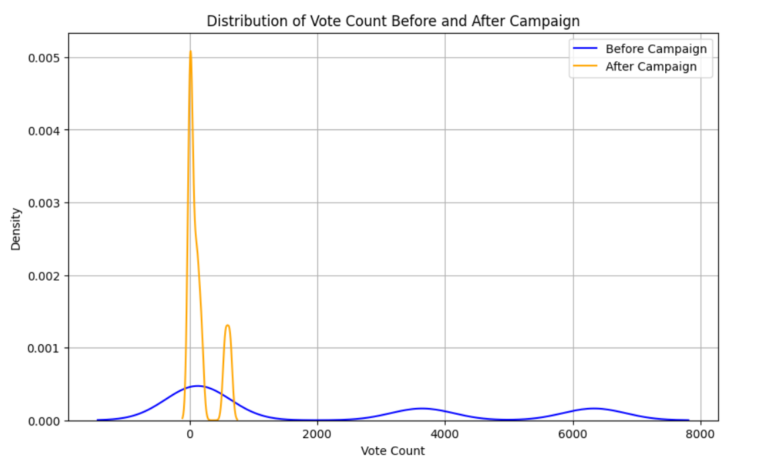

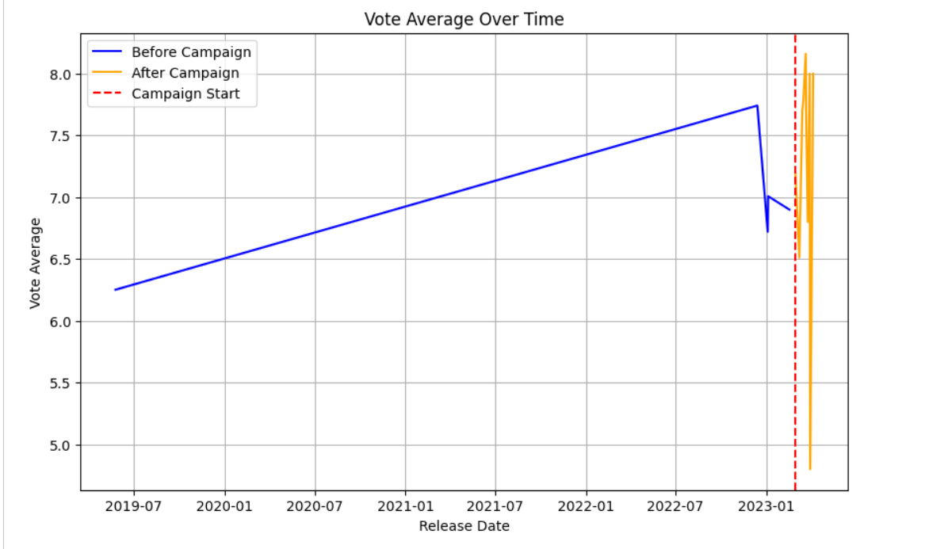

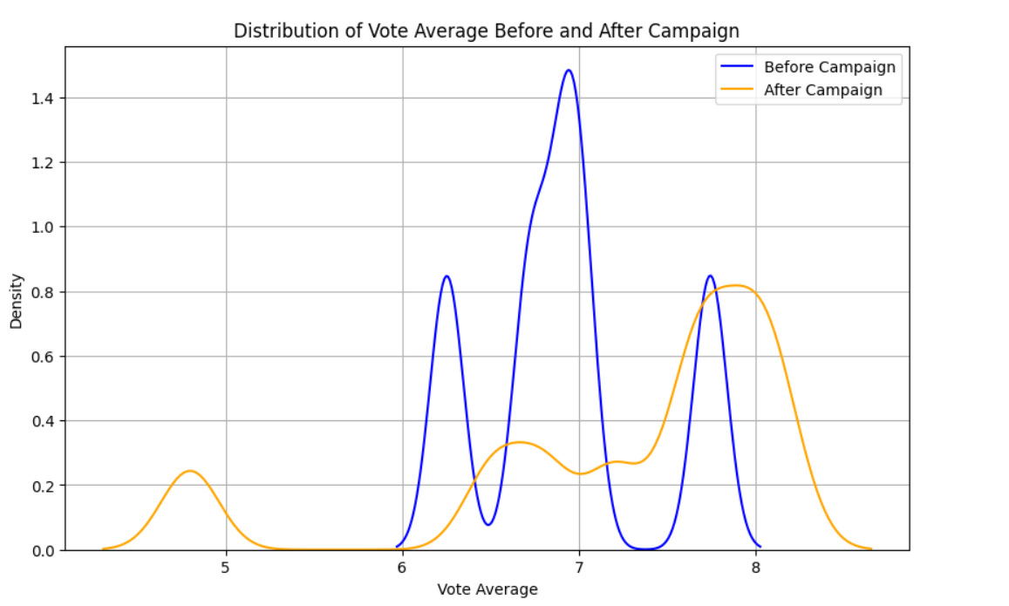

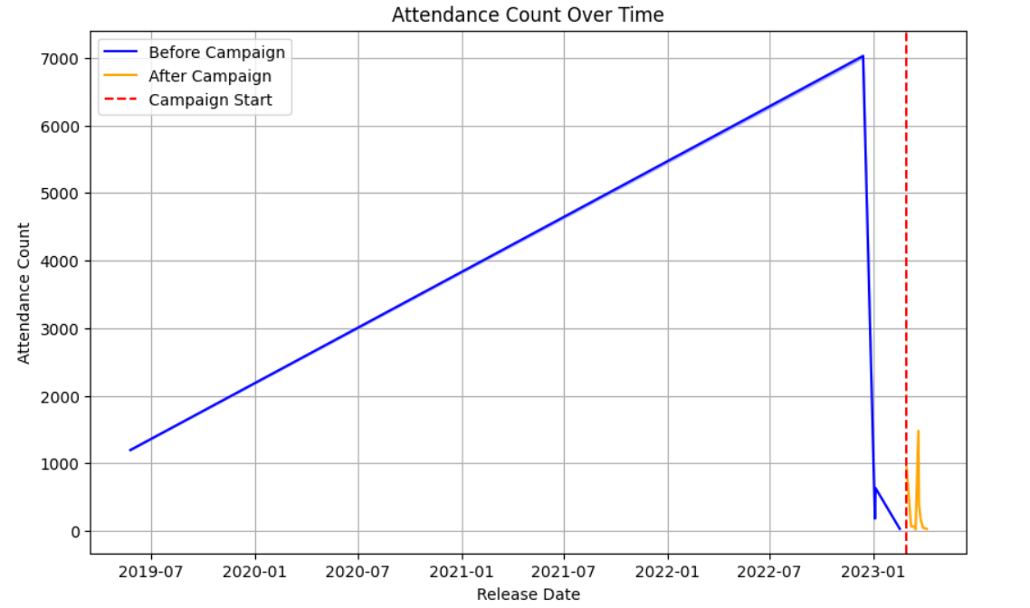

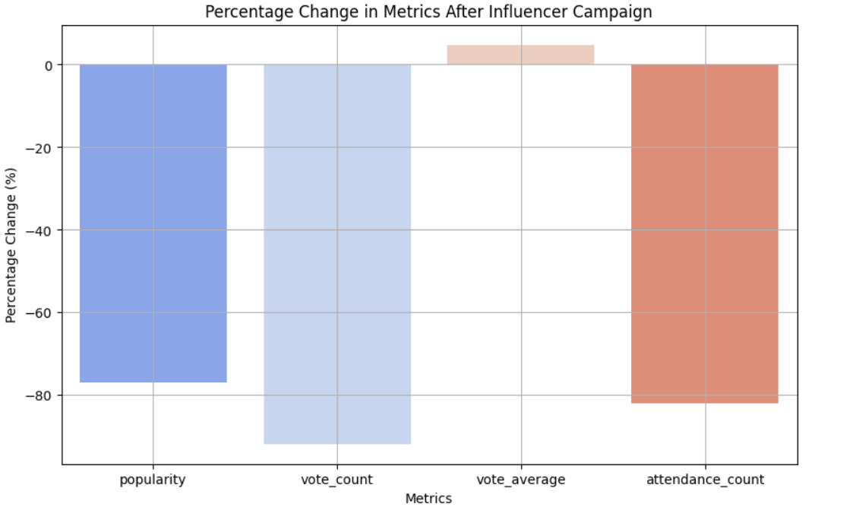

**Progress :**

**Accomplishments**:

* Successfully completed the statistical and visual analysis for all metrics.
* Generated clear visualizations that highlight the influencer campaign’s impact.

**Metrics**:

**Impact on Popularity**:

* + Percentage Change: **-76.96%**
  + t-statistic: **27.40**, p-value: **0.0000**

**Impact on Vote Count**:

* + Percentage Change: **-91.82%**
  + t-statistic: **45.03**, p-value: **0.0000**

**Impact on Vote Average**:

* + Percentage Change: **4.77%**
  + t-statistic: **-23.63**, p-value: **0.0000**

**Impact on Attendance Count**:

* + Percentage Change: **-82.05%**
  + t-statistic: **33.43**, p-value: **0.0000**

# Challenges and Solutions :

**Challenges Faced**:

* Missing or incomplete data for some movies, particularly those with low engagement levels, posed difficulties in drawing reliable conclusions.
* Ensuring the statistical significance of the analysis required a careful approach to filtering and cleaning data.

**Solutions Implemented**:

* Filtered out movies with unreliable or incomplete data points to improve analysis accuracy.
* Focused on movies with sufficient vote and attendance data to ensure reliable results.

# Next Steps :

· **Upcoming Tasks**:

* Incorporate additional influencer campaign data to refine the analysis.
* Extend the analysis to other media types such as TV series or digital streaming content.

**Goals**:

* Evaluate whether different categories of influencers (e.g., micro-influencers vs. macro-influencers) have varying levels of impact.

# Conclusion :

# Summary: The analysis revealed that the influencer campaign had a significant impact on key metrics like popularity, vote count, and attendance. The overall decline in these metrics post-campaign suggests a diminishing trend in engagement, which was statistically significant based on the p-values obtained. The findings provide useful insights for future influencer marketing strategies within the entertainment sector.

# **Acknowledgments**: Thank the audience for their time and attention.

# Instructions:

1. Use Google Docs. Single Column
2. TNR stands for Times New Roman: B - Bold
3. Use images as required with proper references
4. Use charts, tables as per your requirement.
5. Number of Pages: 2 to 8 for each task report.